Allergy Response Plan
Student’s Name:
DOB:
Teacher/Class: School:
ALLERGY TO:
Attach Photo Here
High risk for severe reaction (e.g. hx asthma): Yes No

General Signs of Severe Allergic Reaction:
Systems: Symptoms:
Mouth: Itching and swelling of lips, tongue or mouth
Throat*: Itching and/or a sense of tightness in throat, hoarseness, and hacking cough Skin: hives, itchy rash, and/or swelling of face or extremities
Gut: Nausea, abdominal cramps, vomiting and/or diarrhea
Lung*: Shortness of breath, repetitive coughing and/or wheezing Heart*: “Thready pulse”, “passing out”
Note: the severity of symptoms can change quickly.
*These symptoms can potentially progress to a life-threatening situation.

If Exposure to Allergen is Suspected and/or Symptoms are:

- Give (medicine/dose/route) IMMEDIATELY!
- Then call 911/EMS (ask for advanced life support) following school procedures for 911.
- Call parent/guardian or emergency contacts.
- Call Dr. at ______________
DO NOT HESITATE TO CALL 911!

Trained School Staff
1. Title Room
2. Title Room
3. Title Room

Emergency Contacts (other than Parent/Guardian)
1. Phone:
Relationship:
2. Phone:
Relationship:
Nurse’s signature: Date:
Parent/Guardian signature: Date:
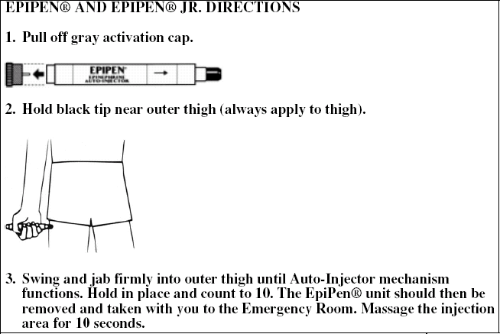
(Adapted from the Food Allergy and Anaphylaxis Network)

Specific training on the Allergy Response Plan (including administration of epi-pen in an emergency if nurse is unavailable) to be given by school nurse to these school staff:
______________________________ ______________________________
______________________________ ______________________________
______________________________ ______________________________

